Department of Computer Science & Engineering
Microprocessor & Computer Architecture Lab

Lab 2,3 and 4 Programs
UE24CS251B

Q1. Write an ALP to subtract if the numbers are equal, otherwise add them.
MOV R1, #10 @alternatively, I also tried 15 here
MOV R2, #10
CMP R1, R2
BEQ EQUAL
ADD R0, R1, R2
B END
EQUAL:
SUB R0, R1, R2
END:
SWI 0x11

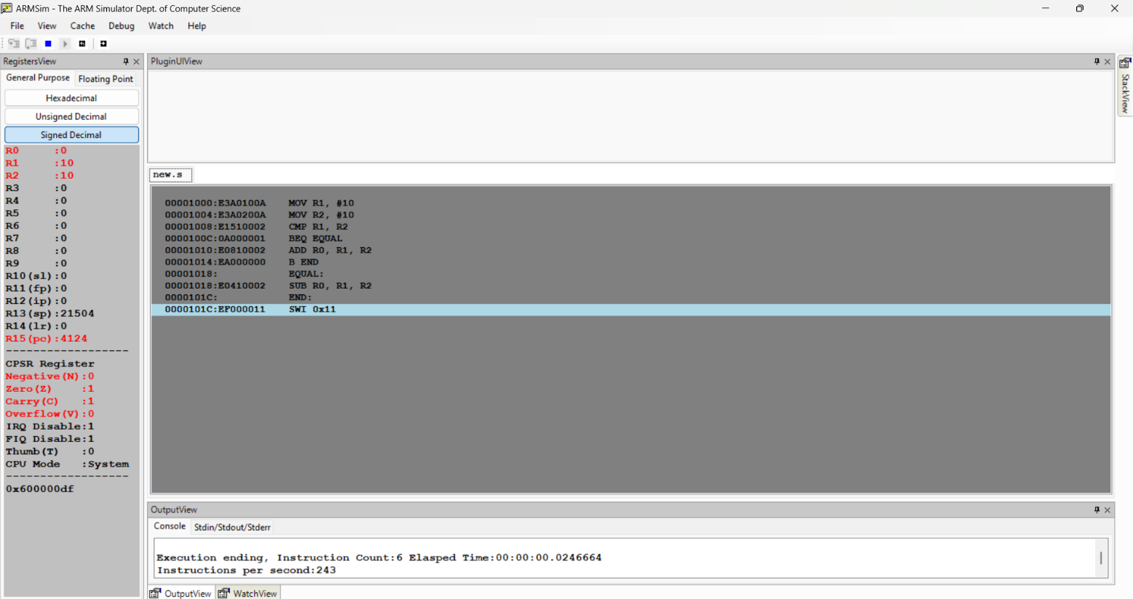
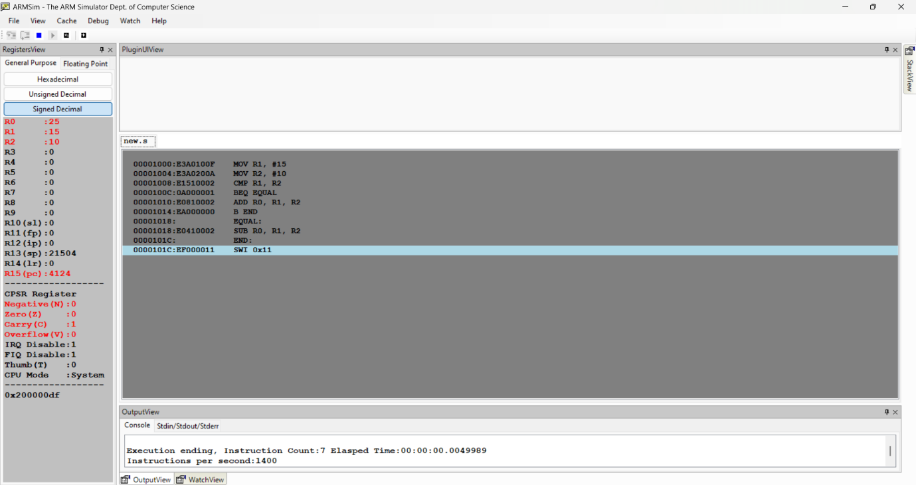

Q2. Check if a given number is even or odd.
Note: at the end of the program execution R2 contains 0 if number is even, otherwise R2 contains 1.
MOV R1, #15 @alternatively, I also tried 10 here
AND R2, R1, #1
SWI 0x11

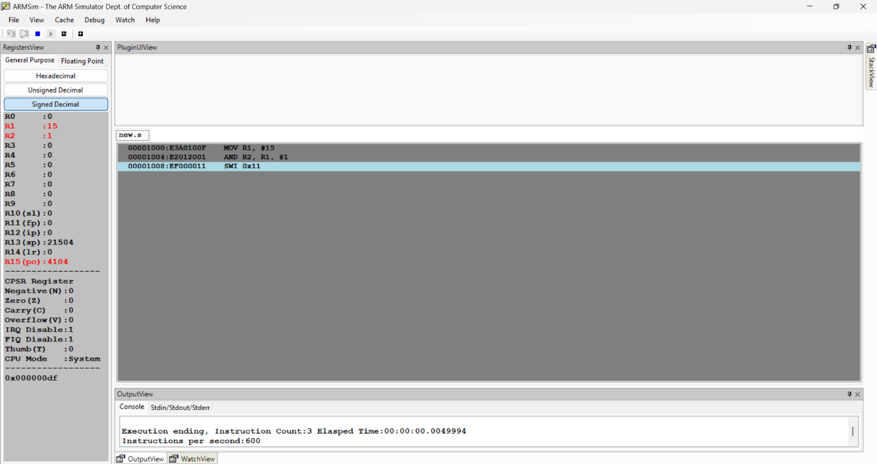
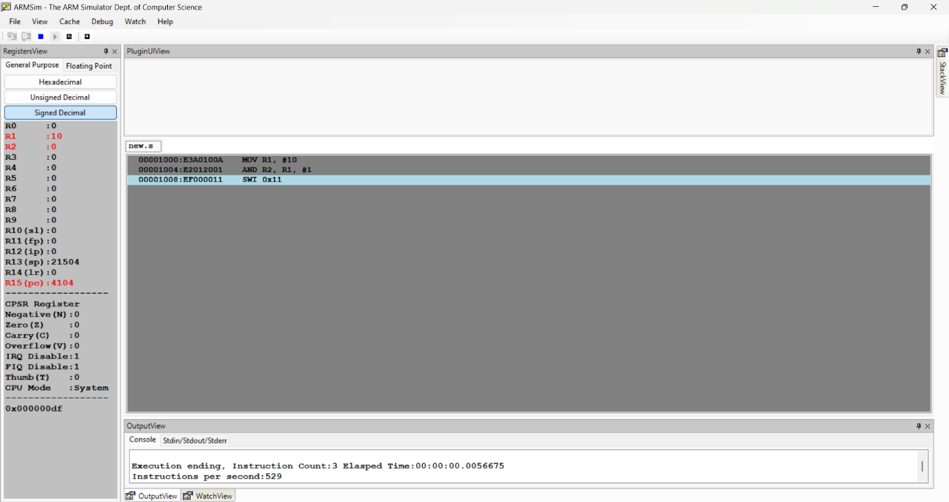
Q3. Based on value of number in r0,
- store 1 in r1 if r0 is 0
- store 2 in r1 if r0 is positive
- store 3 if r0 is negative

MOV R0, #5 @alternatively, I also tried -5 and 0 here
CMP R0, #0
MOVEQ R1, #1
MOVGT R1, #2
MOVLT R1, #3
SWI 0x11

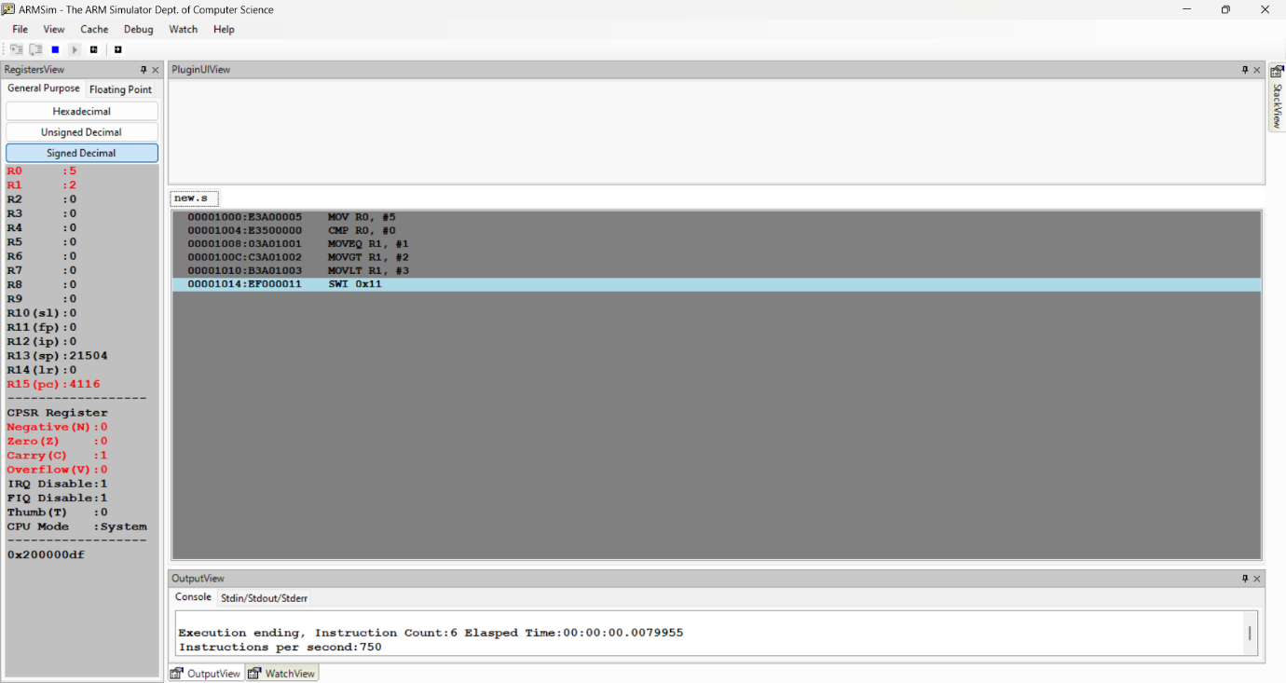
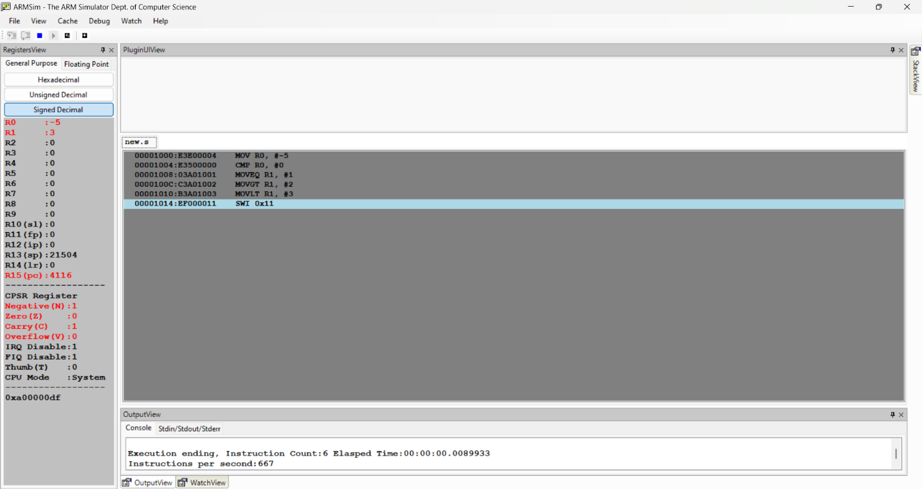
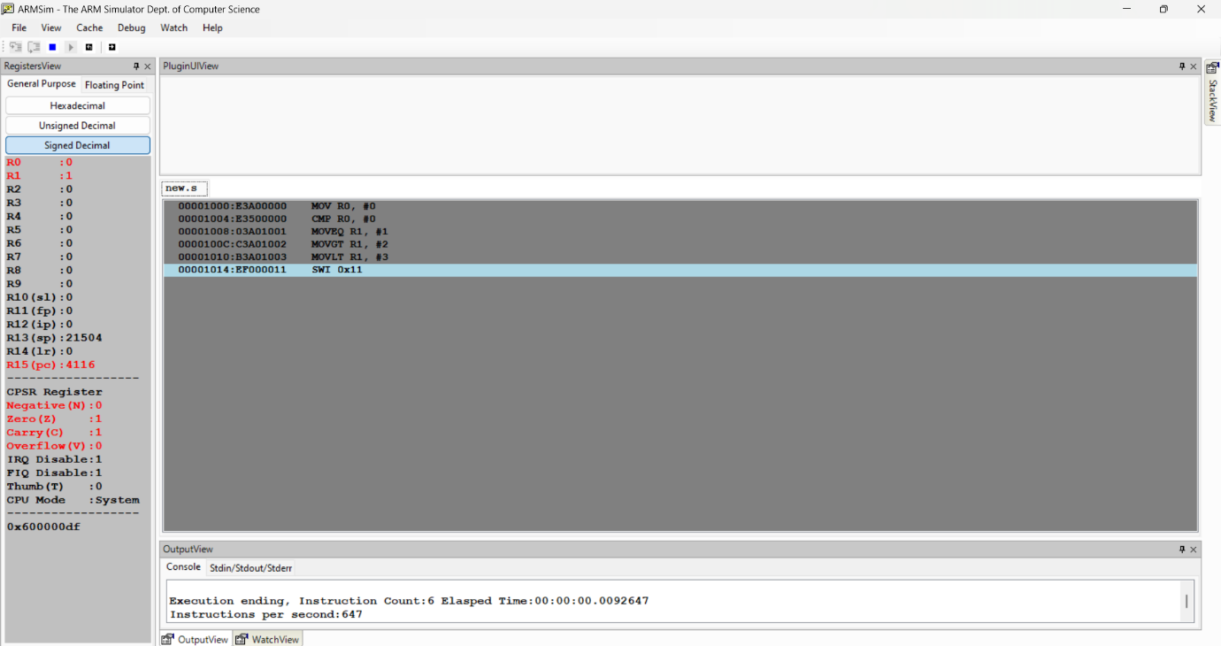

Q4. To find GCD of two numbers.
MOV R0, #24
MOV R1, #18
GCD:
CMP R0, R1
SUBGT R0, R0, R1
SUBLT R1, R1, R0
BNE GCD
MOV R5, R1
SWI 0X11
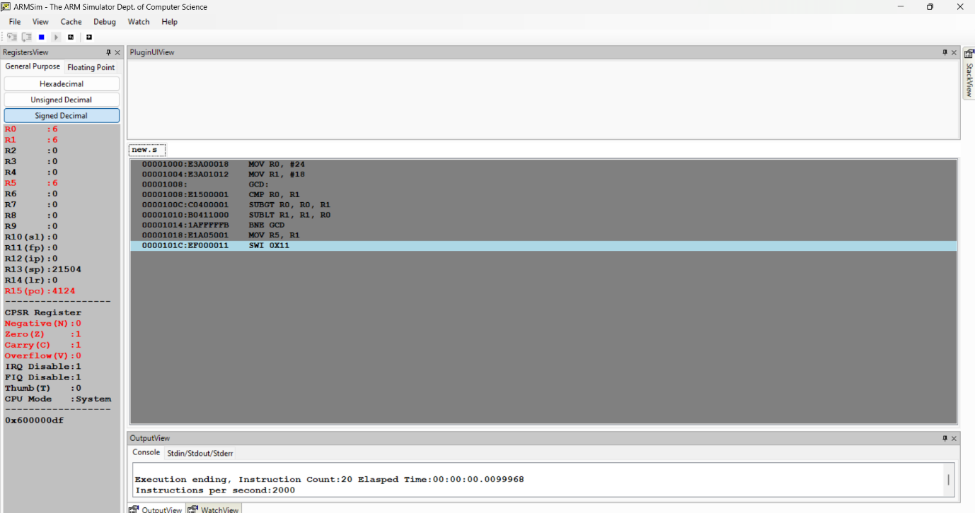

Q5. Write an ALP using ARM7TDMI to add only even numbers stored in memory location for a given set of numbers and store the sum in the memory location.
LDR R0, =DATA
MOV R1, #5
MOV R2, #0
LOOP:
LDR R3, [R0], #4
AND R4, R3, #1
CMP R4, #0
ADDEQ R2, R2, R3
SUBS R1, R1, #1
BNE LOOP
SWI 0x11
DATA: .word 2, 3, 4, 5, 6
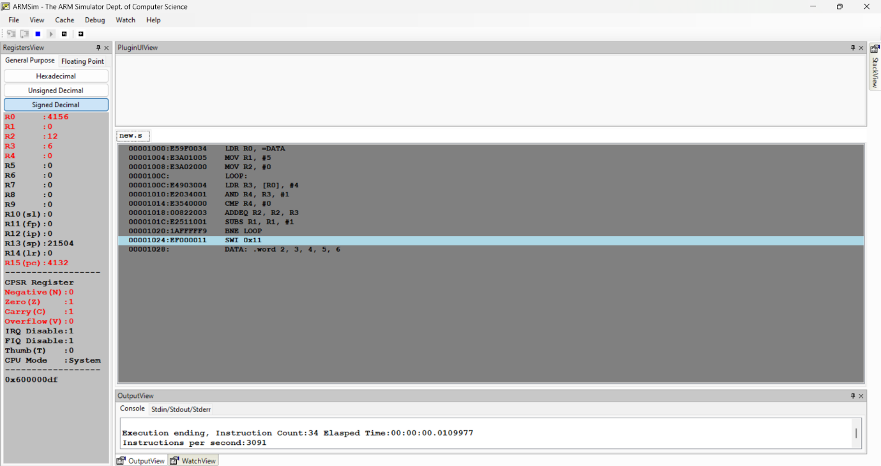

Q6. Write a program to find the factorial of a given number.
MOV R0, #5
MOV R1, #1
FACT:
MUL R1, R0, R1
SUBS R0, R0, #1
CMP R0, #1
BNE FACT
SWI 0x11

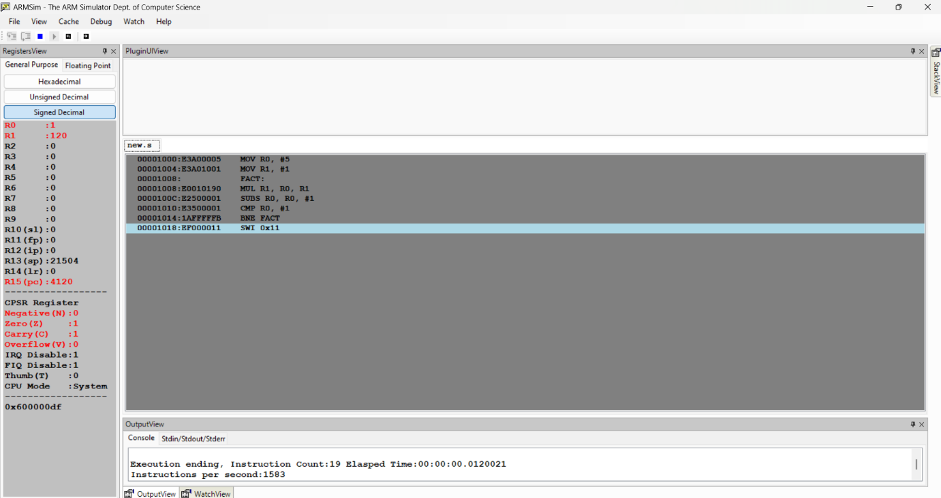

Q7. Write an ALP to find the number of zeroes, positive and negative numbers in a given array
LDR R0, =ARRAY
MOV R1, #10
MOV R5, #0
MOV R6, #0
MOV R7, #0
LOOP:
LDR R2, [R0], #4
CMP R2, #0
ADDGT R5, R5, #1
ADDLT R6, R6, #1
ADDEQ R7, R7, #1
SUBS R1, R1, #1
BNE LOOP
SWI 0X11
ARRAY: .WORD 10, -5, 0, 20, -15, 0, 30, -25, 40, 0

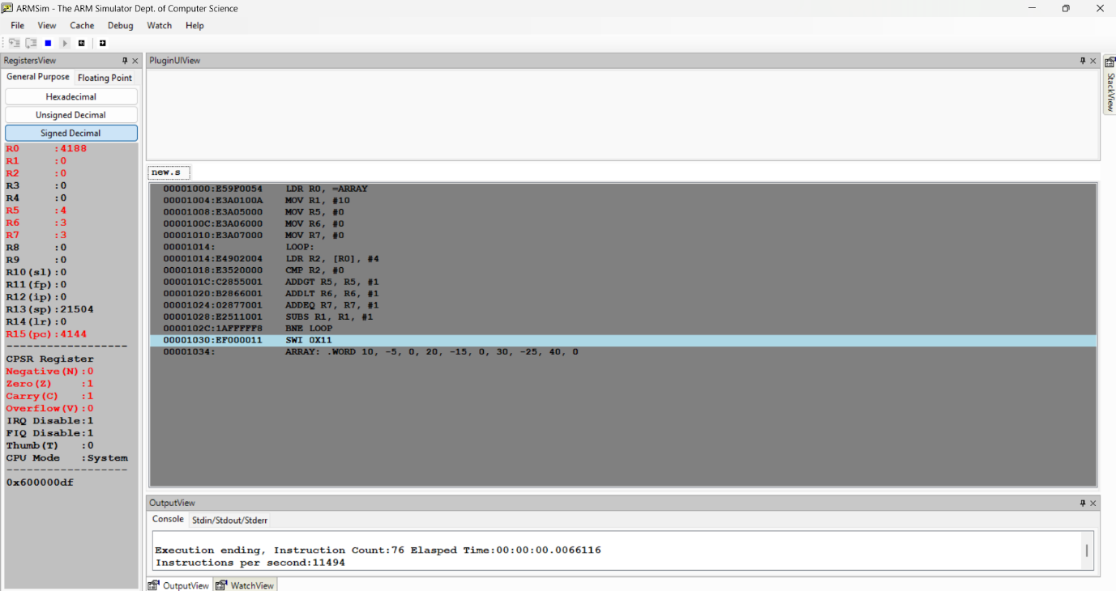

Q8. Write a program in ARM7TDMI-ISA to find the sum of N data items at alternate locations in the memory. Store the result in the memory location.
- Use Pre-indexing addressing mode
- Use Post-indexing addressing mode
- Use Auto-indexing addressing mode

Pre indexed:
LDR R0, =ARRAY
MOV R1, #5
MOV R2, #0
MOV R3, #0
LOOP:
LDR R4, [R0, R3]
ADD R2, R2, R4
ADD R3, R3, #8
SUBS R1, R1, #1
BNE LOOP
SWI 0x11
ARRAY: .word 10, 0, 20, 0, 30, 0, 40, 0, 50

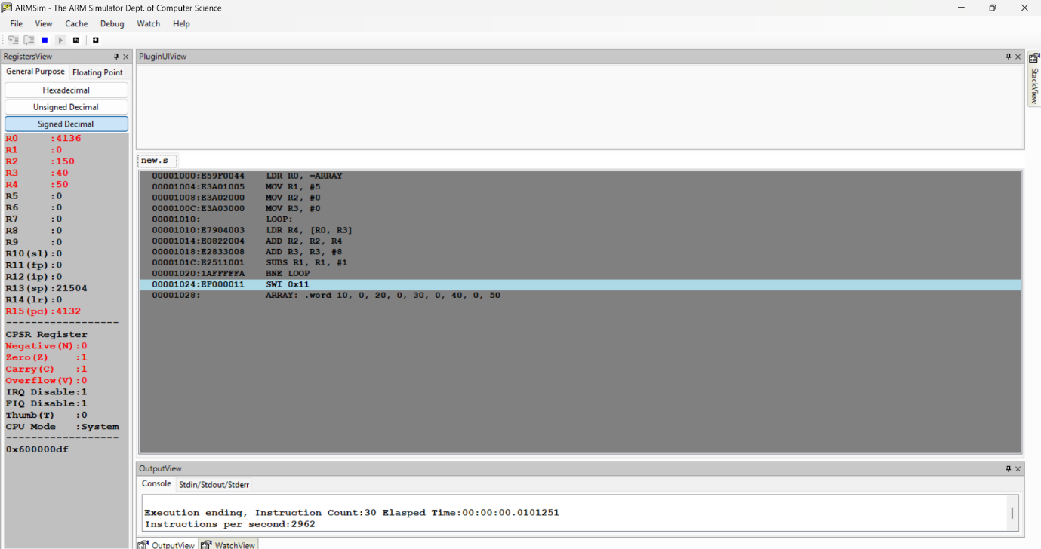

Post indexed:
LDR R0, =ARRAY
MOV R1, #5
MOV R2, #0
LOOP:
LDR R4, [R0], #8
ADD R2, R2, R4
SUBS R1, R1, #1
BNE LOOP
SWI 0x11
ARRAY: .word 10, 0, 20, 0, 30, 0, 40, 0, 50

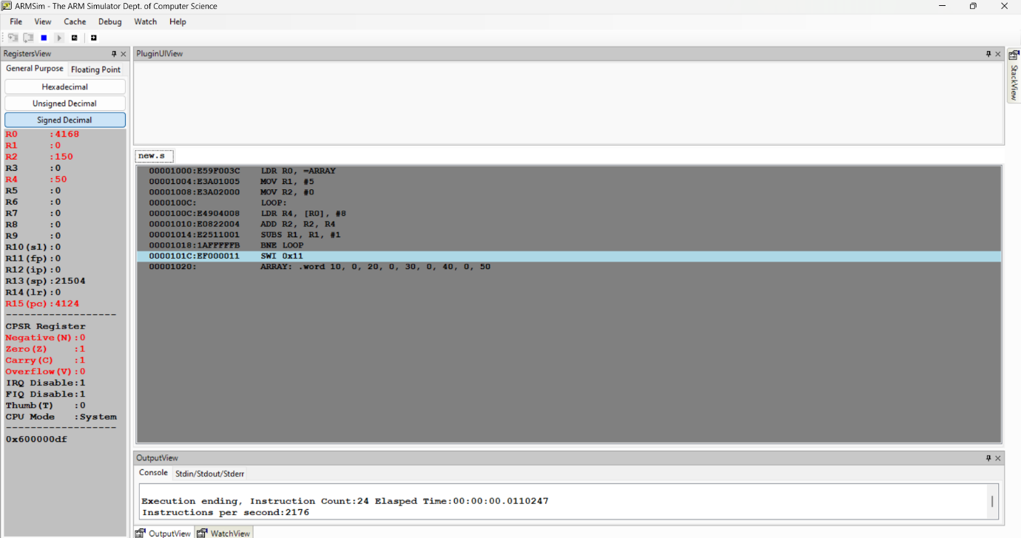

Auto indexed:
LDR R0, =ARRAY
SUB R0, R0, #8
MOV R1, #5
MOV R2, #0
LOOP:
LDR R4, [R0, #8]!
ADD R2, R2, R4
SUBS R1, R1, #1
BNE LOOP
SWI 0x11
ARRAY: .word 10, 0, 20, 0, 30, 0, 40, 0, 50

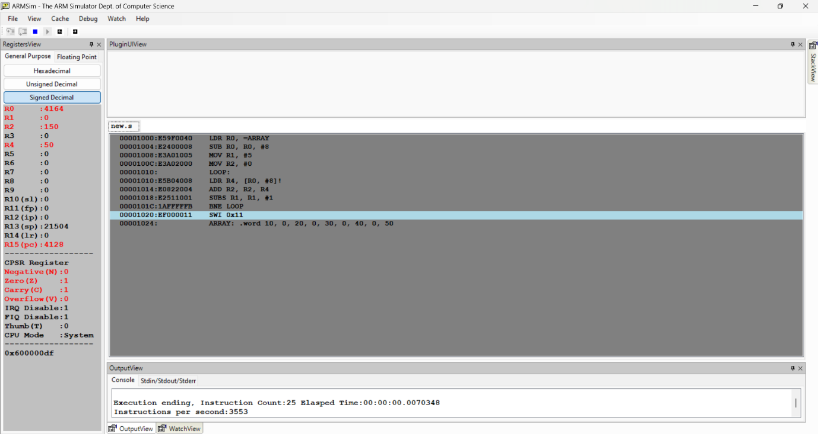

Q9. Write an ALP to perform Convolution using MUL and MLA instruction (Addition of multiplication of respective numbers of loc A and loc B).
LDR R0, =LOCA
LDR R1, =LOCB
MOV R2, #3
MOV R3, #0
LOOP:
LDR R4, [R0], #4
LDR R5, [R1], #4
MLA R3, R4, R5, R3 @ R3 = (R4 * R5) + R3
SUBS R2, R2, #1
BNE LOOP
SWI 0x11
LOCA: .word 1, 2, 3
LOCB: .word 4, 5, 6

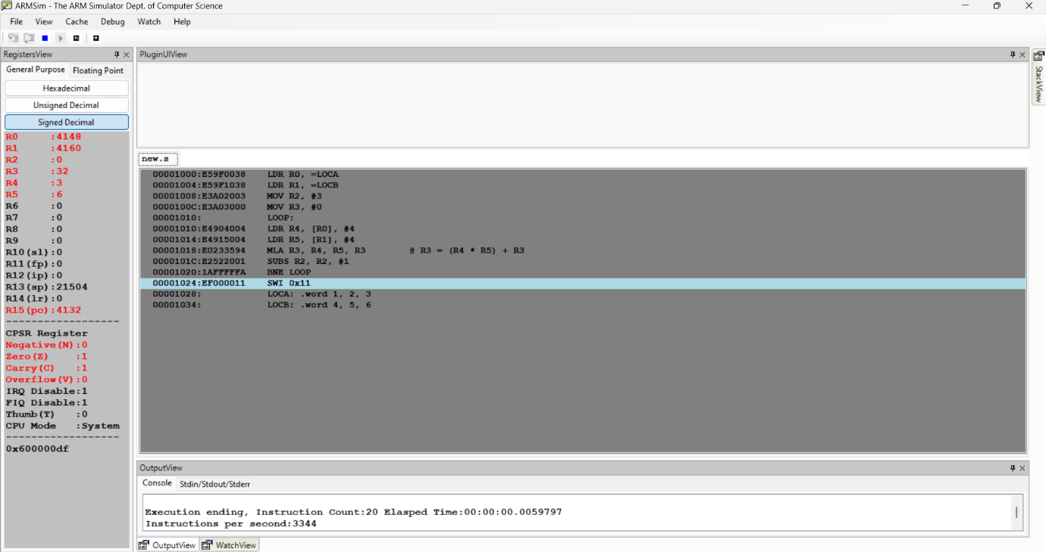

Q10. Write an ARM7TDMI ALP to check whether a given 32-bit number has odd or even parity (number of 1s).
It stores 00 in R7 if parity is EVEN and 01 in R7 if parity is ODD
LDR R0, =NUM
LDR R0, [R0]
MOV R2, #0
MOV R3, #32
LOOP:
AND R4, R0, #1
ADDNE R2, R2, #1
MOV R0, R0, LSR #1
SUBS R3, R3, #1
BNE LOOP
AND R7, R2, #1
SWI 0x11
NUM: .word 15

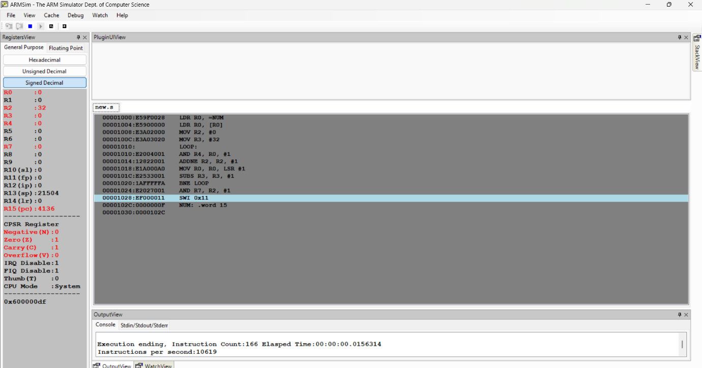

Q11. Write an ARM ALP to perform element-wise addition of two 3×3 matrices using indexed addressing
LDR R0, =MAT1
LDR R1, =MAT2
LDR R2, =RES
MOV R3, #9
LOOP:
LDR R4, [R0], #4
LDR R5, [R1], #4
ADD R6, R4, R5
STR R6, [R2], #4
SUBS R3, R3, #1
BNE LOOP
SWI 0x11
MAT1: .word 1,2,3,4,5,6,7,8,9
MAT2: .word 9,8,7,6,5,4,3,2,1
RES: .space 36



